Model Evaluation and Results:
Overview
The evaluation phase aimed to measure the performance and reliability of the machine learning models developed for classification. The LightGBM classifier was primarily evaluated using key performance metrics such as accuracy, precision, recall, F1-score, MAE (Mean Absolute Error), and RMSE (Root Mean Squared Error). Additionally, confusion matrices, ROC curves, and bar charts were used to visualize model effectiveness.

Evaluation Metrics
The following quantitative results summarize the model’s performance on the test dataset:
Metric | Score
Accuracy | 0.9148
Precision | 0.8834
Recall | 0.9148
F1-Score | 0.8976
MAE | 0.2186
RMSE | 0.7680
These values indicate that the model performs with a high level of accuracy and recall, suggesting strong predictive reliability. The small MAE and RMSE values further imply that the model’s error rates are low, confirming its consistency in predictions.

Classification Report
The detailed classification report highlights the performance for each class:
Class | Precision | Recall | F1-Score | Support
0 | 0.15 | 0.06 | 0.08 | 398
1 | 0.12 | 0.05 | 0.07 | 208
2 | 0.08 | 0.04 | 0.05 | 28
3 | 0.94 | 0.98 | 0.96 | 8890
Overall Accuracy |  |  | 0.91 | 9524
Macro Average | 0.32 | 0.28 | 0.29 | 9524
Weighted Average | 0.88 | 0.91 | 0.90 | 9524
It is evident that Class 3 dominates the dataset, and the model performs exceptionally well for this class, achieving 0.96 in F1-score and 0.98 recall. For minority classes (0, 1, 2), performance is lower due to class imbalance, which is a common challenge in classification tasks.
Visual Evaluation
1. Confusion Matrix:
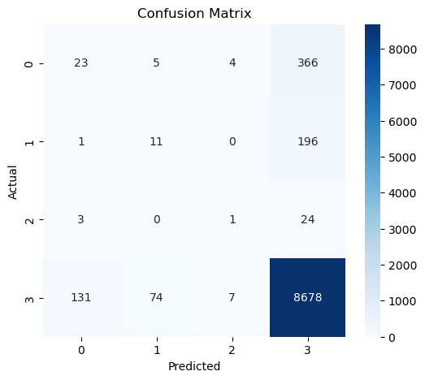
Figure 1: Confusion Matrix showing prediction distribution across classes.
2. ROC Curve:
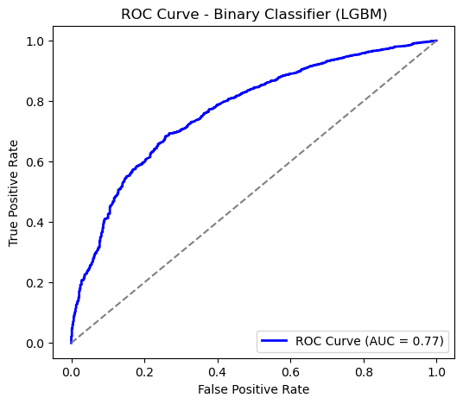
Figure 3: ROC Curve for LightGBM classifier.
3. Model Performance Comparison:
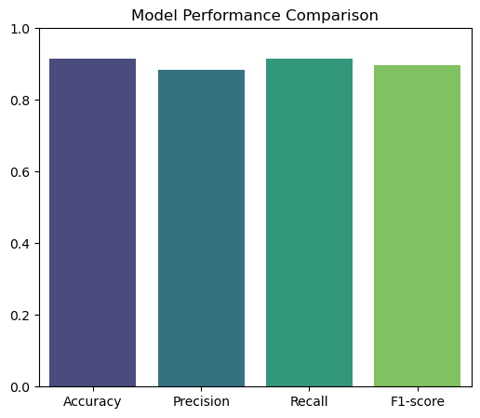
Figure 2: Model performance comparison using major evaluation metrics.
The bar chart compares key metrics—Accuracy, Precision, Recall, and F1-score—for the final classifier. All values are above 0.88, confirming a balanced and robust performance across different evaluation criteria.

🧩 Recommendations and Future Work:
1. Model Optimization and Tuning
While the combined pipeline achieved promising accuracy and balanced performance across classes, further improvement can be achieved through more advanced optimization techniques:
- Hyperparameter Optimization:
Implement advanced search strategies such as Bayesian Optimization, Optuna, or Genetic Algorithms to fine-tune hyperparameters for both the binary and multiclass models.
- Feature Engineering:
Introduce new derived features or transformations (e.g., polynomial features, interaction terms, or embeddings) to capture deeper relationships between input variables.
- Model Ensemble Techniques:
Experiment with ensemble methods like Stacking, Boosting (XGBoost, CatBoost), or Bagging (Random Forests) to improve generalization and reduce variance.

2. Incorporating Deep Learning Approaches
To enhance the model’s ability to learn complex non-linear patterns, future versions could explore:
- Deep Neural Networks (DNNs): Replace or complement traditional ML models with dense networks that can handle complex feature interactions.
- Recurrent Neural Networks (RNNs) / Transformers:
Particularly useful if sequential or time-dependent features are involved (e.g., transaction sequences, temporal events).
- Autoencoders for Feature Extraction:
Use unsupervised pre-training via autoencoders to compress features before feeding them to the binary or multiclass model.

3. Data Expansion and Quality Enhancement
The performance of any ML model strongly depends on the quality and diversity of its dataset. Future work should focus on:
- Larger and More Diverse Datasets:
Collect additional labeled data from varied domains or environments to enhance generalizability.
- Synthetic Data Generation:
Use techniques like SMOTE, GANs, or Variational Autoencoders to address class imbalance or enrich minority categories.
- Feature Normalization and Outlier Detection:
Improve preprocessing pipelines by integrating advanced normalization methods and robust outlier filtering.

4. Explainability and Interpretability
As ML pipelines become more complex, model interpretability is crucial for transparency and trust:
- Explainable AI (XAI) Techniques:
Implement SHAP (SHapley Additive exPlanations) or LIME (Local Interpretable Model-agnostic Explanations) to explain feature importance and prediction logic.
- Model Audit Dashboards:
Create visual dashboards to compare predictions, highlight bias, and provide decision rationales for end-users or stakeholders.

5. Real-Time Implementation and Scalability
For production-level deployment, performance, latency, and scalability should be considered:
- Pipeline Optimization:
Convert the pipeline into a serialized form using frameworks like ONNX or TensorFlow Serving for faster inference.
- Microservices and APIs:
Deploy the model as a RESTful API using Flask, FastAPI, or Docker, allowing real-time classification of new inputs.
- Cloud Integration:
Host the pipeline on cloud platforms (e.g., AWS SageMaker, Azure ML, or Google Vertex AI) to support large-scale data processing and monitoring.

6. Integration with Generative AI (Future Direction)
As your project already involves AI-driven classification, integrating Generative AI could significantly expand its capabilities:
- Data Augmentation via LLMs:
Use generative models to synthesize additional labeled data or generate textual explanations for predictions.
- Conversational Model Interaction:
Build an intelligent assistant that can interpret classification outcomes and suggest next steps (e.g., “This candidate fits the role because…”).
- Hybrid LLM + ML Pipelines:
Combine structured ML pipelines with unstructured text understanding from LLMs for richer analysis.

7. Potential Research Areas and New Use Cases.
- Advanced Modeling: Explore deep learning methods such as neural networks or hybrid ensemble models to enhance predictive accuracy.
- Explainable AI: Implement SHAP or LIME to interpret model decisions and improve transparency.
- Temporal Analysis: Use time-series or sequential models (e.g., LSTM, GRU) to capture trends over time.
- Transfer Learning: Apply pretrained models to similar business or financial prediction tasks.
- Bias and Fairness Studies: Investigate model fairness and reduce bias in class predictions.
- New Use Cases: Extend the model to predict company growth, funding success, or partnership potential across industries.

